MPhil in Public Health / MPhil in Epidemiology
STATISTICS AND COMPUTING

DESCRIBING RELATIONSHIPS: Multiple Regression
Introduction: Extension of linear regression
Model and ANOVA for multiple regression (MR)
Assessing adequacy of fit
Residuals and their plots
Polynomial regression: Non-linear trends
Model selection: Testing coefficients in MR
Example using SPSS
F-test for extra variable(s)
Three approaches to model building: Forwards entry

Backwards elimination
Stepwise
Settling on a model
Further topics: Dummy variables for categorical variables

Interaction in models
Logistic regression for yes/no responses

Dr Chris Palmer

Centre for Applied Medical Statistics
Dept of Public Health and Primary Care, Institute of Public Health
University of Cambridge
INTRODUCTION
Multiple regression is a body of techniques that generalizes simple linear regression to cope with more than one explanatory/predictor (x) variable.
Simple linear regression aims to:
- Describe the ‘best-fitting’ linear relationship
between a response variable (y)
and an explanatory variable (x)
- assess the goodness-of-fit of such a model
- use, if appropriate, the linear model to make predictions over a valid range of x-values.
Multiple regression seeks to:
- Accommodate several, possibly inter-related, explanatory variables
(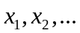) into a regression model
- handle non-linear relationships
- assess adequacy of fit
- predict responses over valid ranges of x-values.
In simple linear regression, the emphasis is on “is there a linear trend?” and, if so, “how good is this trend to explain variation?”
In multiple regression, the emphasis is on “which variables are most influential on the response variable?” and “how many variables are worth including in a model?”
MODEL AND ANOVA FOR MULTIPLE REGRESSION
The model for response  is for i=1, 2,…, n
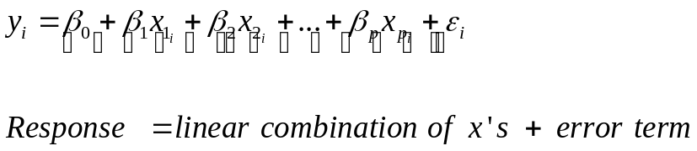
where, as usual, the random part is assumed ~ 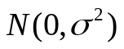.
Again the principle of least squares is used to estimate the parameters
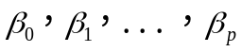 from the data.
ANOVA takes the form:

Source | D.F. | S.S. | M.S. | F | P
Regression | p | SS_{REG} | MSR |  | .
Residual | n-p-1 | SSE | MSE
Total | n-1 | 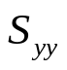

The F-test is a composite test of
i.e. to see if all the predictor variables are irrelevant or not.

Assessing adequacy of fit
The analogue to Pearson’s correlation in a multiple regression is the quantity R2. Just as in simple linear regression, R2 measures the strength of association by partitioning sums of squares:
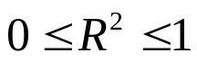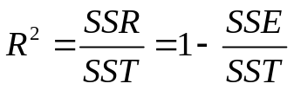
This is usually quoted as a percentage (from 0% to 100%).
Note:
R2 depends on p, the number of predictor variables in the model. Hence it is valid to compare R2 with models having an identical number of predictor variables. To compensate for the fact that R2 invariably increases as the number of terms in the model increases, use adjusted R2 to take the size of the model into account.
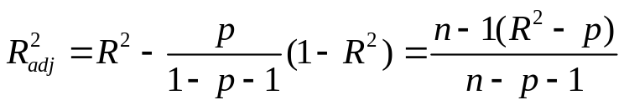

Residuals and their plots
- On most computer packages, residuals can be stored and hence printed or plotted.
- As we have seen before, a good fitting model produces a cloud of points void of obvious patterns.
- An estimate of is obtained from MSE, as in linear regression before. A small is an indication of a good fitting model.
POLYNOMIAL REGRESSION
A special case of multiple regression that looks for non-linear relationships.
Fit model 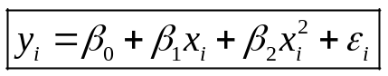 for example.
We would do this if a linear model was inadequate, perhaps with residual plot showing curvature.
Generally, do not go beyond squared terms, although in principle we could fit a model with a polynomial of higher degree.
Note: SPSS handles quadratic and cubic regression in one variable as an option on scatterplots.

MODEL SELECTION
Q. Why not put as many conceivable explanatory variables as possible into a multiple regression equation?
A.

Q. How do we set about choosing a reasonable number of explanatory variables?
A.

Q. How do we know if we have the ‘best possible’ model?
A.
Example Regional expenditure in 1981/82
(Data from Woodward & Francis)
 | 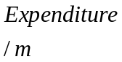 | 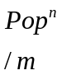 | 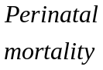 |  | 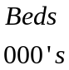
Northern | 677 | 3.1 | 13.2 | 1569 | 34
Yorkshire | 772 | 3.6 | 13.9 | 1867 | 29
Trent | 925 | 4.6 | 11.3 | 2280 | 31
E Anglia | 394 | 1.9 | 10.4 | 997 | 13
NW Thames | 868 | 3.5 | 10.7 | 2035 | 27
NE Thames | 928 | 3.7 | 11.1 | 2015 | 28
SE Thames | 879 | 3.6 | 12.1 | 1935 | 27
SW Thames | 697 | 3.0 | 10.7 | 1580 | 25
Wessex | 562 | 2.8 | 9.9 | 1505 | 19
Oxford | 449 | 2.4 | 9.4 | 1215 | 13
S Western | 681 | 3.1 | 11.4 | 1849 | 24
W Midlands | 1058 | 5.2 | 12.8 | 2651 | 36
Mersey | 560 | 2.4 | 12.4 | 1281 | 21
N Western | 962 | 4.0 | 12.4 | 2056 | 31
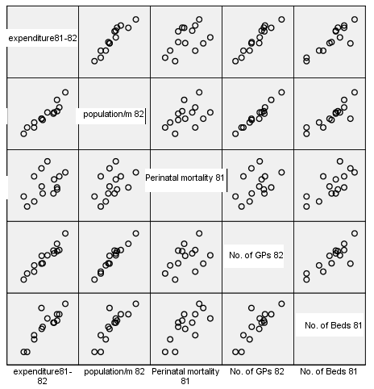
Correlations
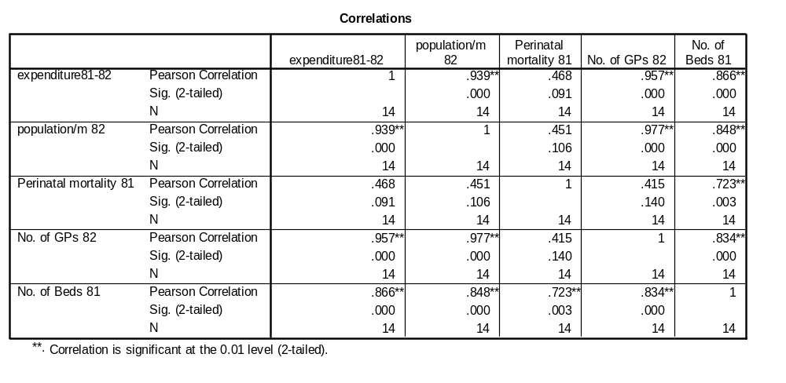
TESTING COEFFICIENTS IN MULTIPLE REGRESSION
In any regression, we can test specific terms in the model for their significance. Formulae exist for 95% C.I.’s for 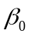
95% C.I.’s for 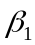 etc.
as well as 95% C.I.’s for at specified 
and 95% C.I.’s for 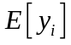 at specified .
Related to these are hypothesis tests for the  coefficients.
SPSS produces output to show the significance of individual terms in a regression equation. This is helpful in comparing terms across models and within the same model (though recall the multiple testing problem-- adjust p-value cutoff!).

Regression
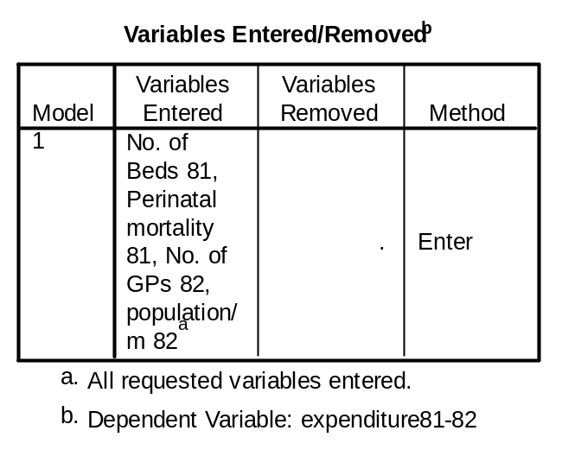
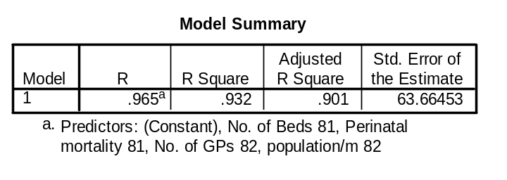
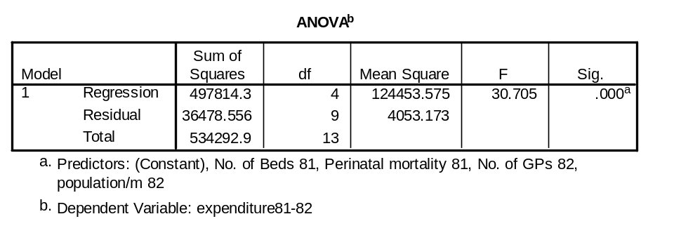
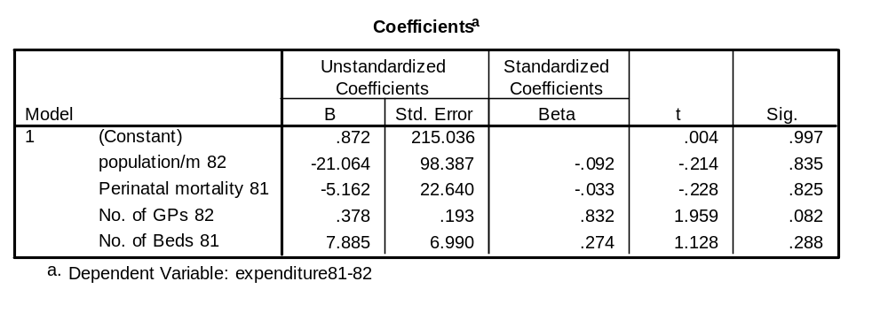

DOES ADDING AN EXTRA VARIABLE MAKE A DIFFERENCE？
To answer this, we need to perform two separate regressions, one with and one without the ‘extra variable’ included. Next, we need to compare the corresponding outputs. Formally, we perform an F-test to determine whether the extra variable is making a statistically significant contribution. If it is not, we can drop it from our model.
For example, in RHA data, could we have used a smaller model? If entering just one variable to account for expenditure, choose the one most correlated.If choosing two variables, the same argument would suggest using the second highest correlated variable, ‘Population’ (correlation=0.9386), but note that Population and GP’s are themselves highly correlated (0.9773). Thus, if GP’s are already in the model, the addition of Population may well not add a significant extra contribution.
The correlation matrix suggests this is ‘GP’s’ (correlation=0.9570).
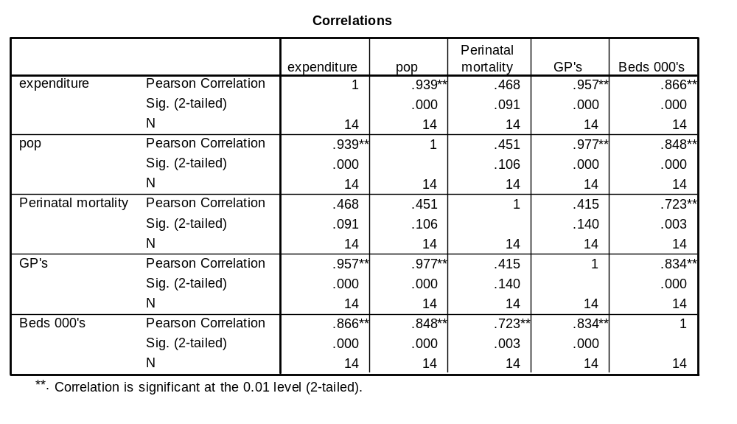To judge such things, we need to use the formal F-test procedure, with help from the computer!
Population and GP’s are themselves highly correlated (0.9773)

Regression-”model” 1 Beds and GPs
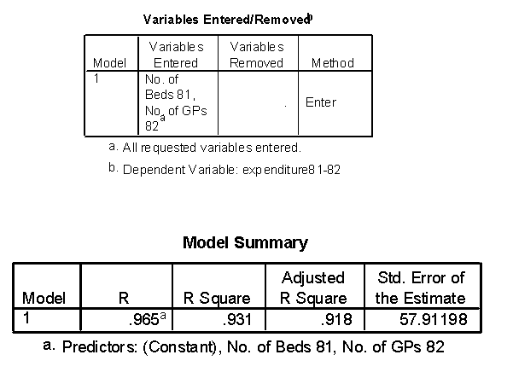
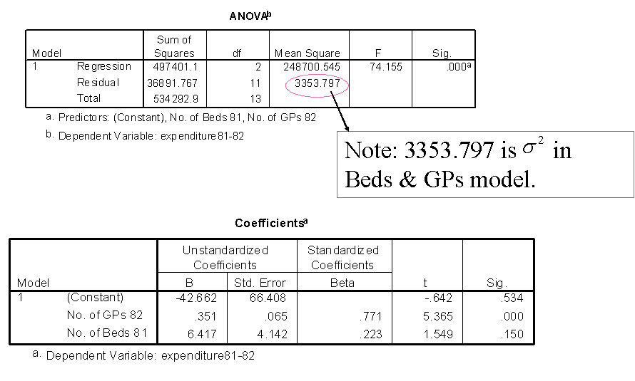

Regression-”model 2 ” GPs alone
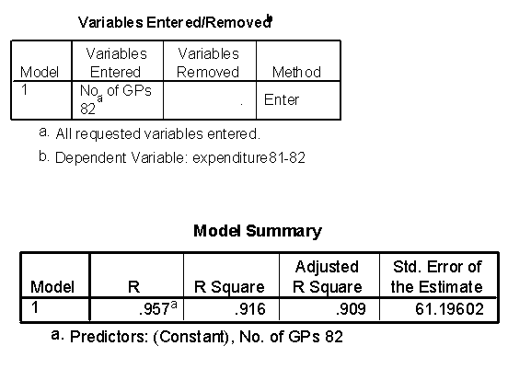
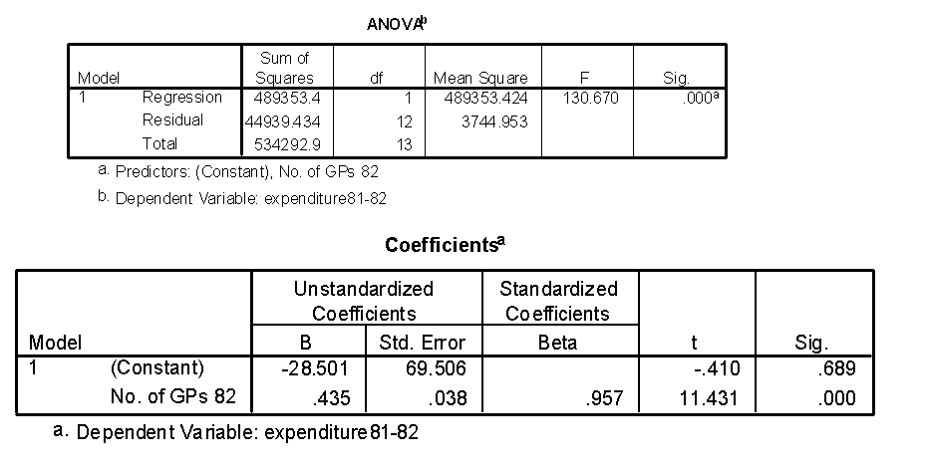
Note: “GPs alone” model, as expected, is not quite as good as “Beds & GPs” model.

Regression-”model 3 ” Beds alone
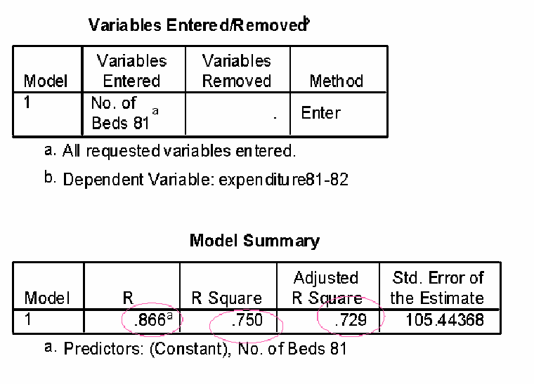
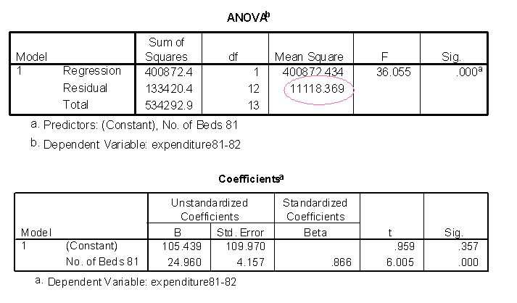
Note: “Beds alone” model is worse than “GPs alone” model.

F-TEST FOR SIGNFICANCE OF EXTRA VARIABLE
We shall compare Model 1: GP’s and Beds
with Model 2: GP’s
i.e. is the number of beds in a district a useful extra variable (beyond knowing the number of GP’s)?
Step 1 Evaluate additional regression sum of squares
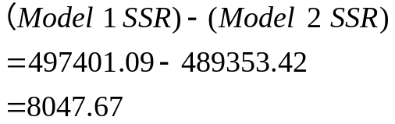

Step 2 Compute
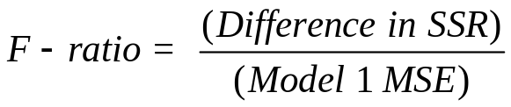
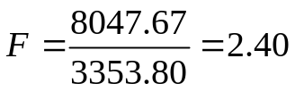
Step 3 Compare F-value with tabulated F-distribution with (1,k) df where k=df associated with Model 1 MSE.
Here k=11, and 2.40 is not significant: the p-value is between 0.1 and 0.2.
Step 4 Infer not a useful addition to model if p>0.05; or that it is a useful addition if 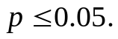

Notes: 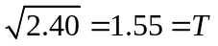 and ‘Sig T’ = 0.15 form the Beds + GP’s model. The F-test generalizes to comparing (m,k) df F-distribution if we are comparing two models, the larger having m more variables.

THREE APPROACHES TO MODEL BUILDING
(1) Forward Entry
Explanatory variables are added one at a time, always choosing the one most highly correlated with the dependent variable from among those not yet in the model, until the addition is no longer a significant improvement on the existing model.
Example:
Regression-modelling “bg120”, all variables entered.
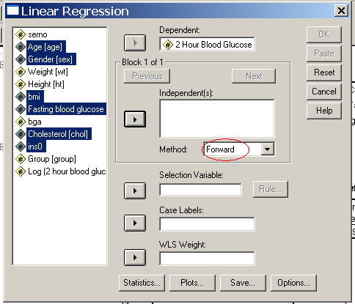

Results:
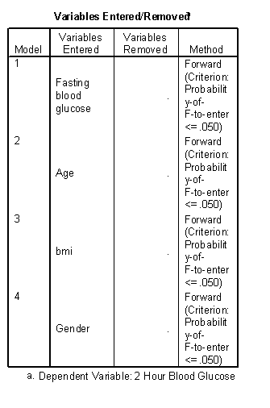
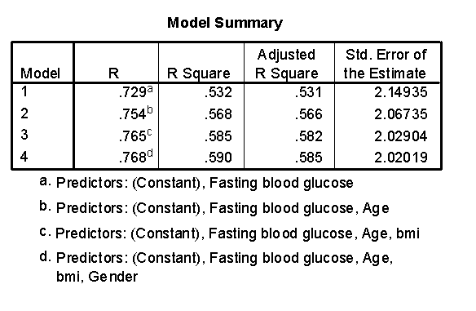
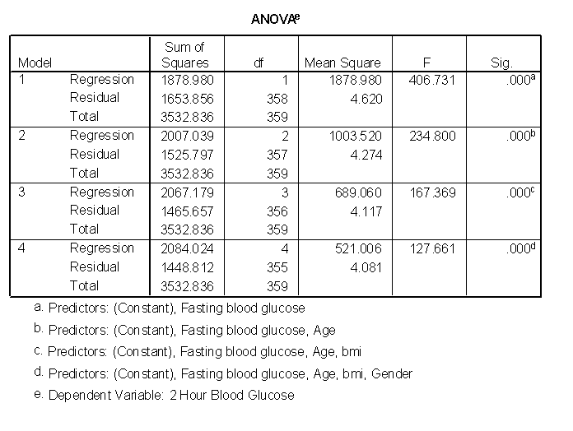
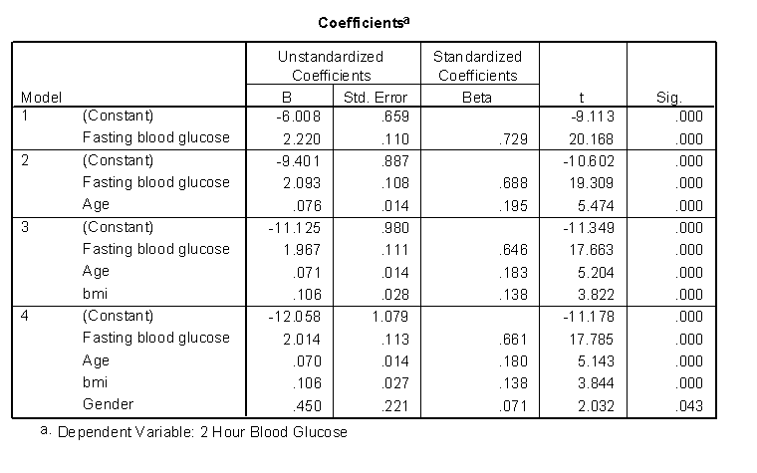
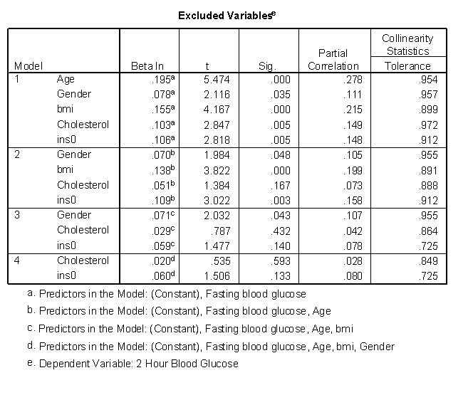

(2) Backwards Elimination
Begin with a set of (potential) explanatory variables. Delete the least helpful one, one at a time until we are no longer deleting significant variables.
- Regression-modelling “bg120”, backwards elimination.
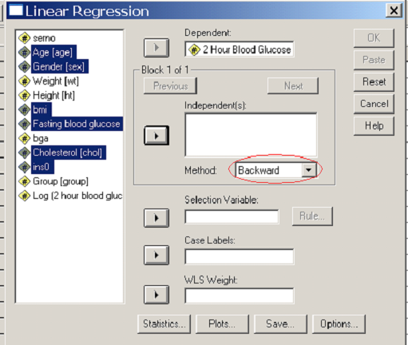

Results:
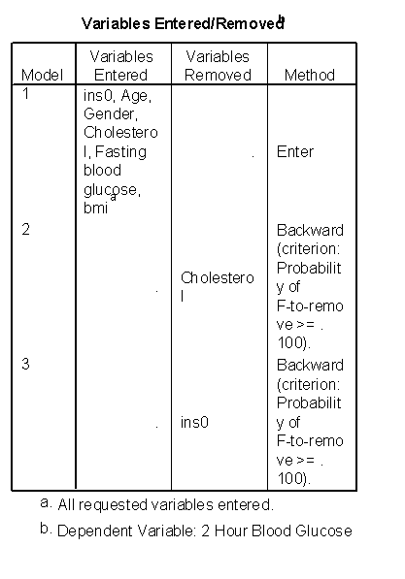
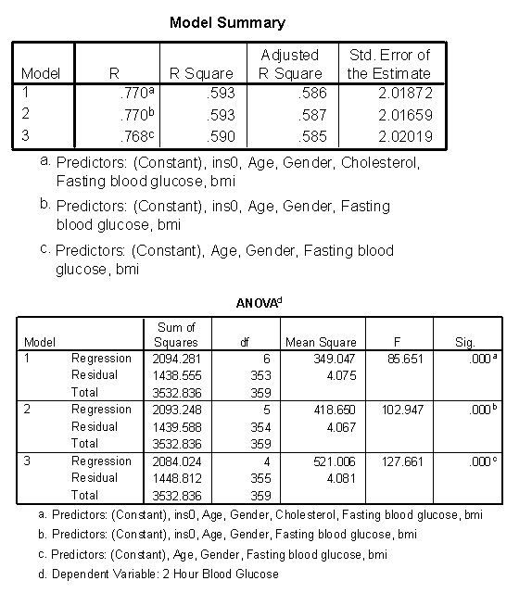
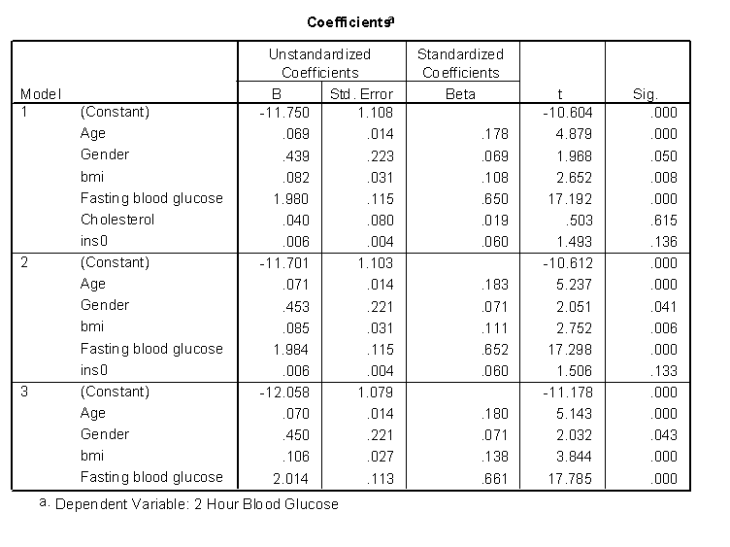
(3) Stepwise Regression
A combination of (1) and (2) where after each step of including one more variable, the procedure checks terms already in the model—that they continue to remain significant.
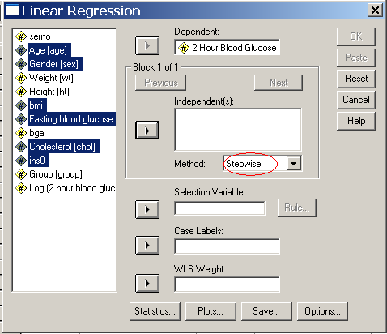

SETTLING ON MODEL
- Sometimes it is fairly clearcut, that from among the set of potential explanatory variables, say precisely two of them make a good model, by whichever approach, and that adding a third variable does not help (being non-significant).
- However, sometimes approaches (1) and (2) give different models, or perhaps inclusion of an extra variable is of borderline significance.
- In such cases, we need to use judgment:
What is the purpose of the model?
How complex/simple can it be?
How many variables in relation to sample size?
- As part of model selection, and also to distinguish between two competing models, make the usual checks of residuals, e.g. plot residuals vs. predicted values, and histogram of residuals.
- Ideally, we aim to produce a model that is simple yet comprehensive—a contradiction in terms admittedly.
If it is too simple, an important relationship may be missed.
If it is too complex, we may end up modeling mere ‘quirks’ of our dataset (not generalities).
Therefore, the most useful model is a suitable compromise.
- Once produced, and checked that it is suitable, a good multiple regression equation is a powerful tool. It encapsulates inter-dependencies among explanatory variables such that the effects of any one variable are adjusted for the effects of all the others.
- Such a model is very useful for description and prediction purposes (so long as ‘sensible’ values of x-variables are chosen).

FURTHER TOPICS
- To cope with categorical data as an explanatory variable can
- use a score or variable itself, if ordinal, or
- create dummy variables (if not ordinal).
Example: if marital status was deemed important, we cannot let
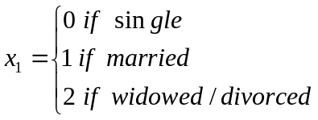
be included. Instead, let
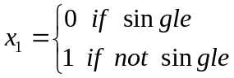
and 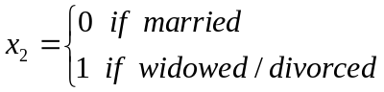
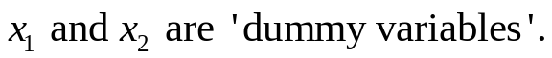
- If interactions are present, meaning, say, an effect for height itself depends on something else, like age, we can include both height, age and their product (heightage) as a separate term.
- If response is a proportion, instead of a continuous variable, there is a similar technique called ‘logistic regression’.
SUMMARY: MULTIPLE REGRESSION CONCEPTS

- Multiple regression is a commonly used, important technique used:
- To remove the effects of ‘nuisance’ variables in a study
- To explore possible prognostic variables
- To develop a prognostic index form several explanatory variables for predicting a variable of interest.
(2) We aim to build (select) a model that is the most suitable compromise between:


(3) Check the model of choice with:
